M5 Blade Firmware Upgrade steps:-
- Go to the server and take the pre evidence for LUN boot order & boot policy details.
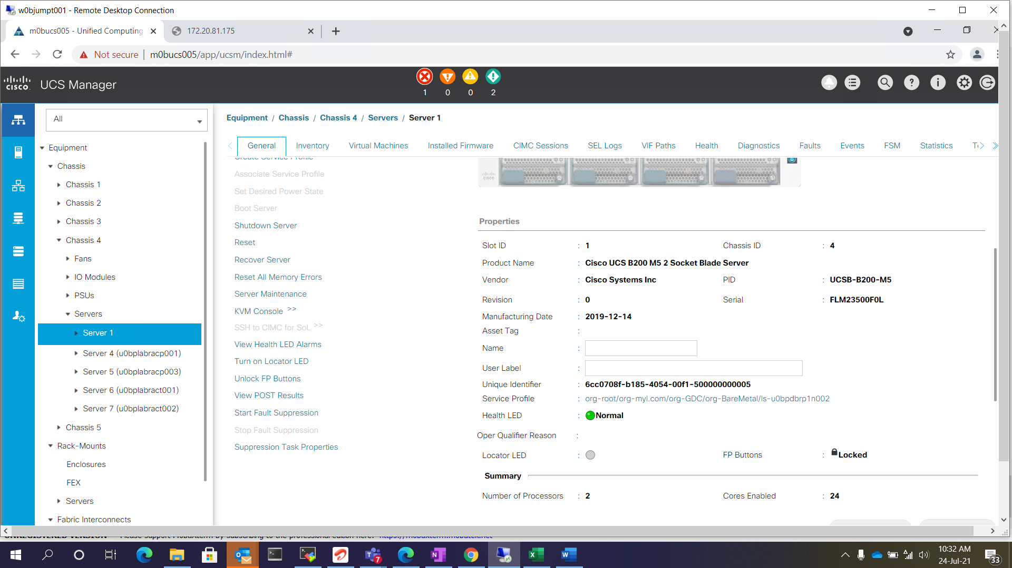

- Click the service profile and select the boot order.
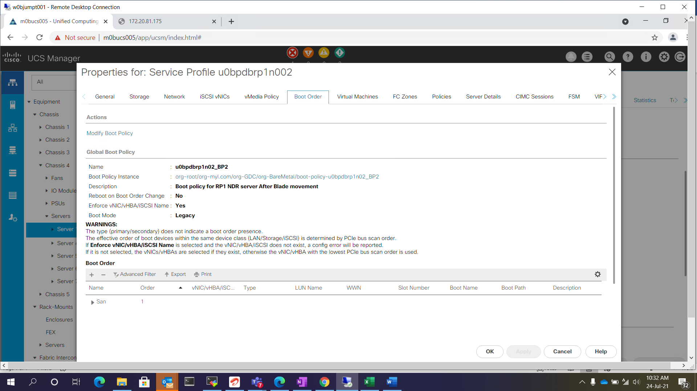
- Take the boot LUN and boot order details screen shots
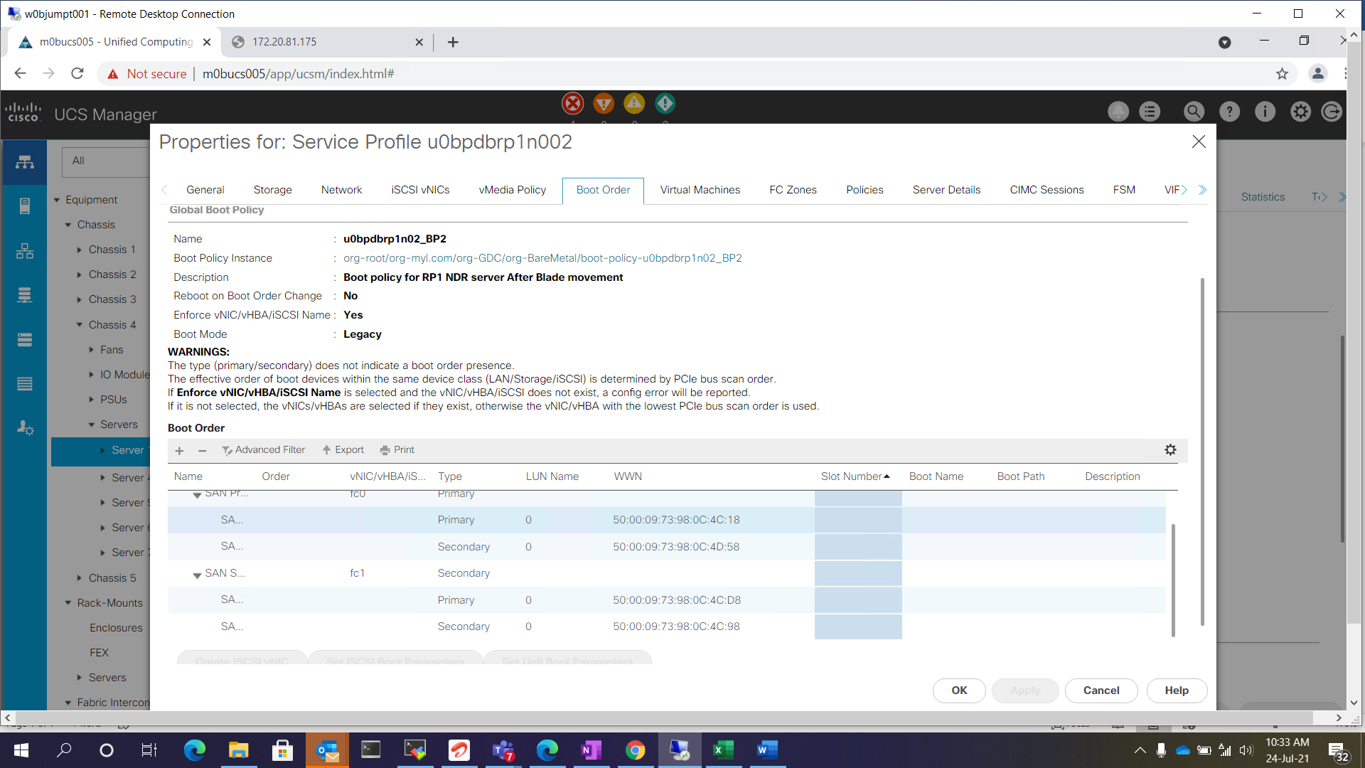

- Click the boot policy and take the evidence.
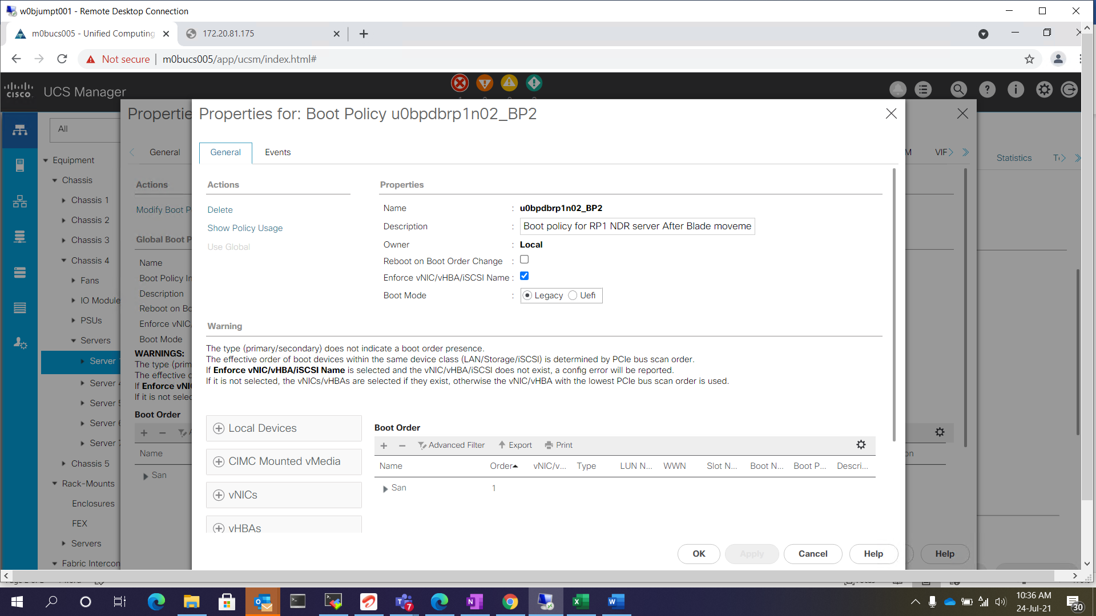

- Once pre-evidence are captured and shutdown the server.
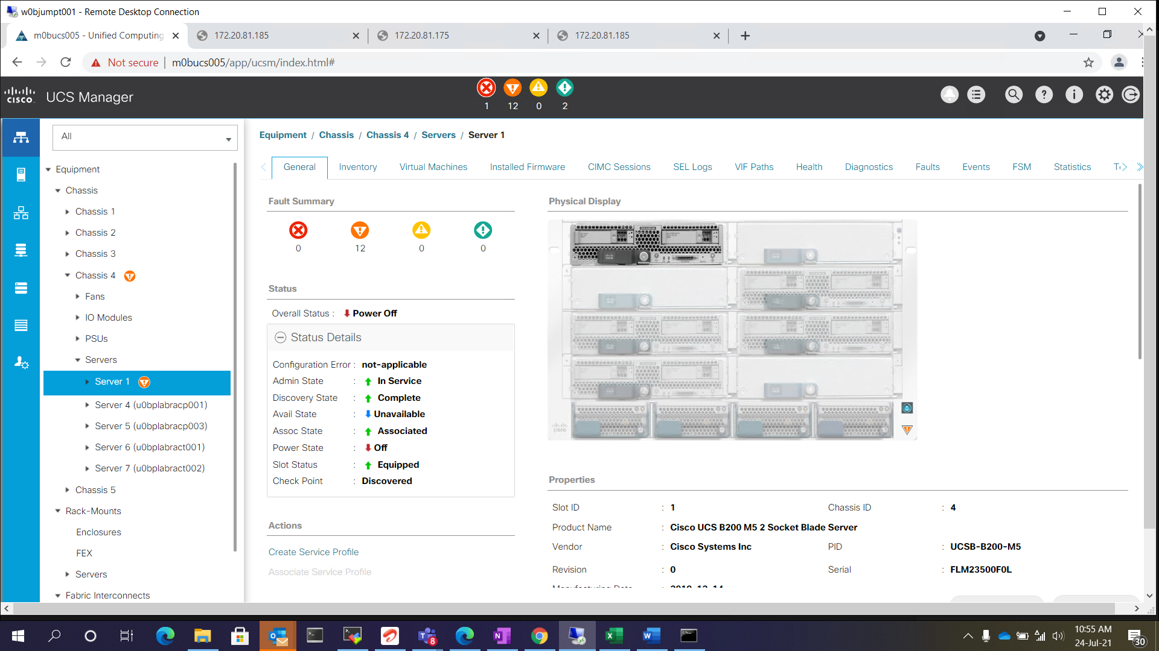

- Click the service profile and go to the policies tab and select the firmware version , which need to be upgraded.
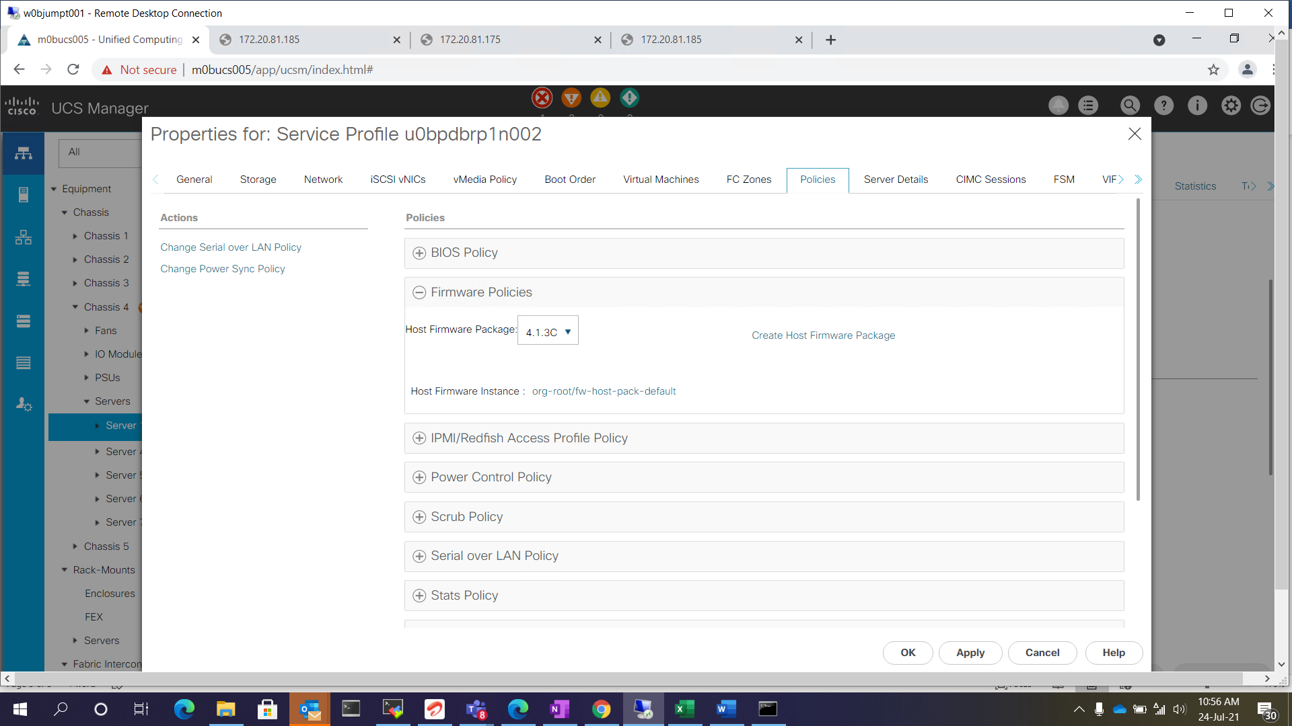

- Apply and save the changes and firmware will be upgrade automatically.
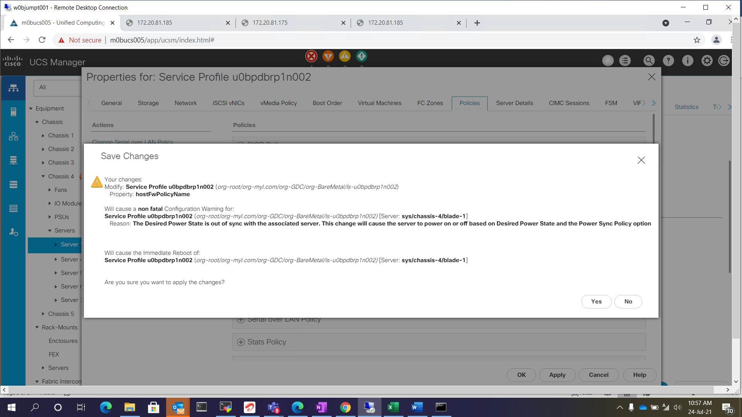

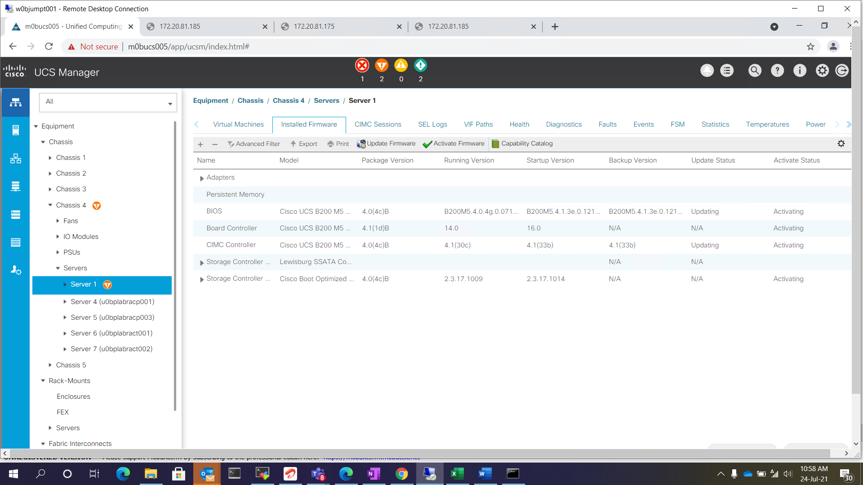

- Go to the FSM Tab and monitor the firmware upgrade status.
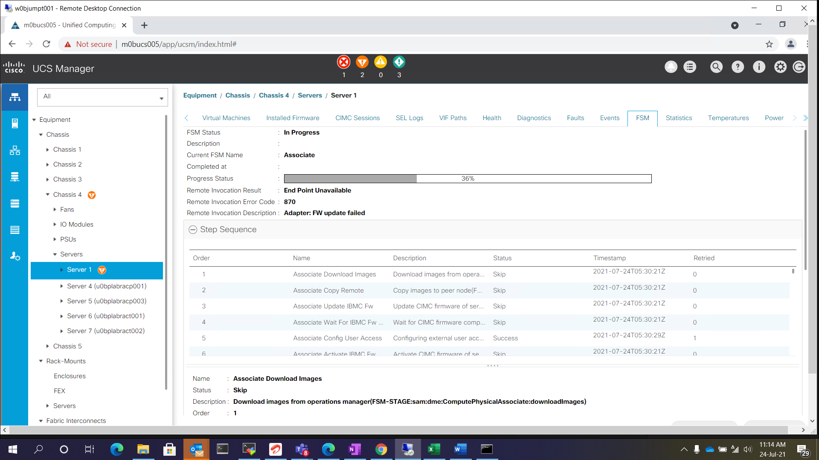

- Once firmware is done check the firmware updated. And power on the servers and validate the server functionality.

